AP Calc AB Name: _______________

______________ _____________

WS Assessment

Target 15:

Approximating areas under the curve

**I can:**

* Interpret the meaning of areas associated with the graph of a rate of change in context.
* Approximate a definite integral using geometric and numerical method
* Interpret the limiting case of the Riemann sum as a definite integral

Unit 6: Integration and Accumulation of Change

HW Target 15

Unit 6 Progress Check FRQ A and B

What you'll learn about: Riemann Sums; terminology and Notation of Integration; The Definite Integral; Computing Definite Integrals on a Calculator … and why?

The definite integral is the basis of integral calculus, just as the derivative is the basis of differential calculus

Find the area under the curve y = x2 + 1 and above the x-axis and bounded by the line x = 0 and x = 2. (Area between x = 0 and x = 2).

|  |  |  |
| --- | --- | --- |
| Right Rectangle Approxi. RRAM Right Riemann Sums | Left Rectangle Approxi. LRAM Left Riemann Sums | Midpoint Rectangle Approxi. MRAM Midpoint Riemann Sums |
| As we divide it into 4 rectangles, what is the total area of these 4 rectangles. (n = 4) | | |
|  |  |  |

We can do a better job by divide it to more rectangles. How about 8 rectangles, what is the total area of these 8 rectangles?

|  |  |  |  |
| --- | --- | --- | --- |
| Number of rectangles | RRAM | LRAM | MRAM |
| n = 4 |  |  |  |
| n = 8 |  |  |  |
| n = 16 |  |  |  |
| n = n | Extra credit – see me for help | | |

Sigma notation Σ (sigma) stands for “sum”

$$\sum_{k=1}^{n}{a_{k}}= a_{1}+a_{2}+a_{3}+…+a_{n}$$

The process to find the sum by dividing the area in to rectangles like above is called Riemann Sum, where

$$A=\left(length\right)\left(width\right)=\sum_{k=1}^{n}{f(c_{k})∆x}$$

Length is the value of function of the curve and width $∆x=\frac{b-a}{n}$

We come up with a new notation to express and is named as define integral (Leibniz's notation

As the number of rectangles getting to very large

$$\lim_{n→∞}{\sum_{k=1}^{n}{f(c_{k})∆x}=\int_{a}^{b}{f\left(x\right)dx}}$$

Rewrite the integral as a limit $\int_{1}^{3}{\left(3x^{2}-2x+5\right)dx}$ =

Definition: If y = f(x) is nonnegative and integrable on [a, b], then the **area under the curve**

**y = f(x) from a to b** is the integral of f from a to b $\int_{a}^{b}{f\left(x\right)dx}$

In the chart below, a definite integral has been provided for you. If a definite integral has been provided, write the corresponding limit of a Riemann sum.

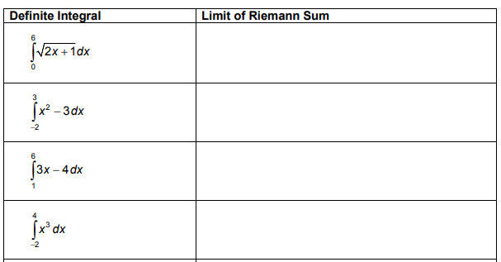

Evaluate the integral $\int_{-2}^{2}{\sqrt{4-x^{2}}dx}$ by sketch the function and geometry. Check by calculator.

If an integrable function y = f(x) is nonpositive, then we get the “negative” area, need to turn it

$A=-\int_{a}^{b}{f\left(x\right)dx}$

In general, for integrable function = (area above the x-axis) – (area below the x-axis)

Be watchful here, it is not equal the total area

Use calculator find the following integral, explain what happens

Sketch to illustrating Y1 = sinx ; Window Y = [-2, 2] Yscl = 1 X = [-2π, π] Xscl = π/4

$\int_{0}^{\frac{π}{2}}{sin\left(x\right)dx}$ $\int_{0}^{π}{sin\left(x\right)dx}$ $\int_{0}^{2π}{sin\left(x\right)dx}$ $\int_{π}^{2π}{sin\left(x\right)dx}$

Integral of a Constant. Evaluate $\int_{9}^{3}{5dx}$. Sketch the picture

A train moves along a track at a steady 75 miles per hour from 7:00 am to 9:00 am.

a. Express its total distance traveled as an integral.

b. Evaluate this integral using calculator

c. Find the total distance travel using your physic knowledge

I hope by now, you fully understand why the area under the velocity curve is the distant travel on your mini project and **never forget it.**

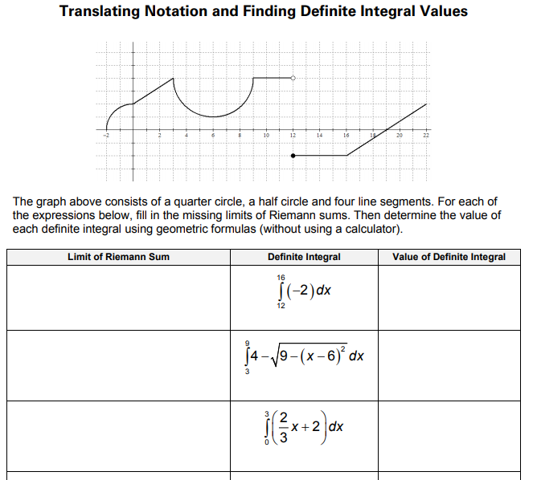

We have learned the Riemann sum with LRAM, RRAM and MRAM. You probably noticed that

MRAM was generally more efficient in approximating integrals than either LRAM or RRAM, even though all three RAM approximation approached the same limit. Are there any other geometric shapes with known areas that can do the job more efficiently? The answer is yes, and the most obvious one is trapezoid.

|  |  |
| --- | --- |
| Midpoint Rule | Trapezoid Rule |

Use midpoint rule and trapezoidal rule to estimate $\int_{1}^{2}{x^{2}dx}$ with 4 partition compare the error of these two methods bases on the actual value of the integral.

Simpson Rule: The numerical integration technique known as "Simpson's Rule" is credited to the mathematician Thomas Simpson (1710-1761) of Leicestershire, England. His also worked in the areas of numerical interpolation and probability theory.

Using n = 4 and all three rules to approximate the value of the integral and compare the result.

Assessment

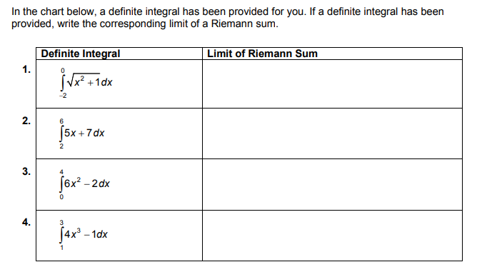

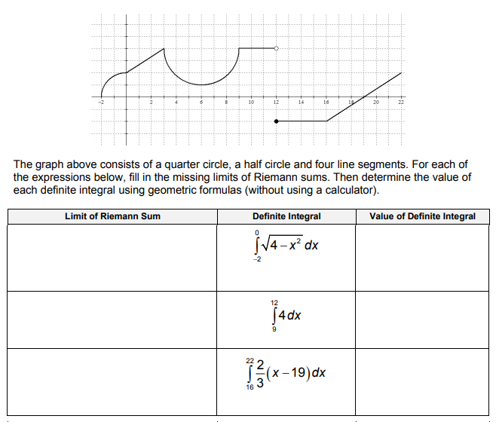

Rewrite the integral $\int_{0}^{2}{{(x+1)}^{2}dx}$ as a limit of Riemann sum. Let n = 4 find this sum by all 5-approximating method.